**An update from the Friends Committee (January 2025)**

With the end of one year it is but a brief pause before the programme for the new year gets underway and with it the Friends involvement. Looking back on 2024 the contribution of the Friends to the museum can be found in the sponsorship they provided for the Rolt Conference and the ‘Stars to Cells’ exhibition but also in the amount of volunteering the Friends contributed to the museum.

Last year Sharon Sinclair, the Museum’s Volunteer Coordinator, calculated volunteers contributed something in excess of 17,500 hours of volunteering in support of the museum, a sizeable number of which would have been delivered by members of the Friends of Ironbridge Gorge Museum. The Friends provided programmes of guiding at Coalbrookdale Museum of Iron, Coalport China Museum, Jackfield Tile Museum and the Broseley Pipeworks along with curatorial duties at the Darby Houses and the ‘Science of Iron’ exhibition at Coalbrookdale as well as supporting the Tar Tunnel Tours; the ‘Steam Team’ were to be found working on projects at Coalbrookdale and Blists Hill whilst the Craft Group provided decorations for Christmas displays and the Costume Team, outfits for the demonstrators at Blists Hill. A dedicated team also worked in the Museum’s Archives cataloguing and scanning photographs, documents and other archival material.

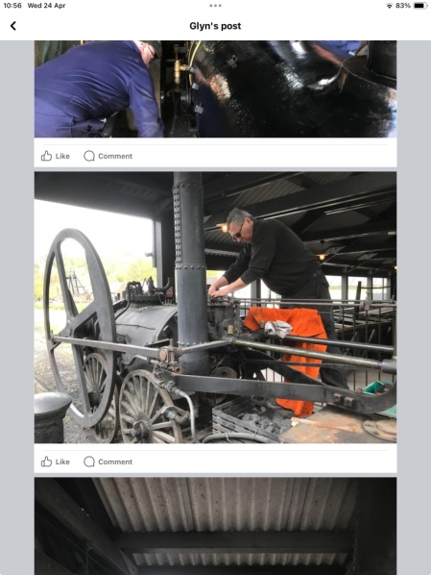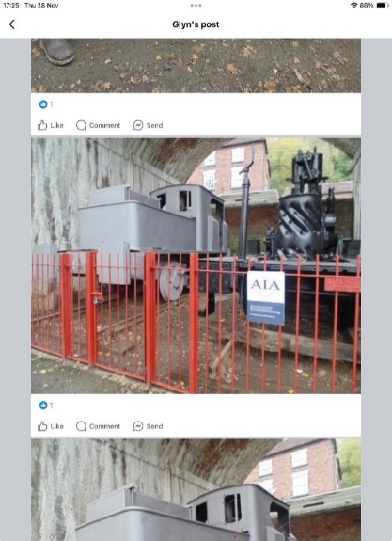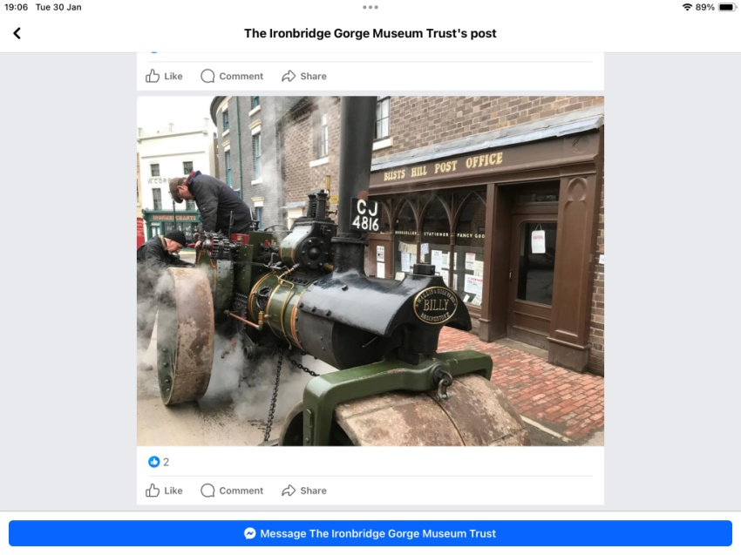

‘Steam Team’ volunteers working on ‘Billy’ the Road Roller and the replica Trevithick engine at Blists Hill as well as evidence of progress in rescuing the Sentinel engines at Coalbrookdale.

So whether you are an aspiring engineer keen to get your hands on a steam engine, a budding Archivist anxious to delve into the history of the Ironbridge Gorge or a crafter able to offer your skills, there is a role in which you can contribute through the Friends to the success of the Museum. It might be your organisational skills that can best help or your ability to tell a good tale, whatever it is there will be a way you can help as a Friend. Even if it is just a wish to keep busy, gain first hand experience to enhance your CV, meet new people or share your skills you will be doing something with a sense of purpose that supports such a world renowned museum.

The support of the Friends to the Ironbridge Gorge Museum Trust throughout the past 55 years has been acknowledged by the Trust as being vital to its existence, helping in its mission to preserve, interpret and explain the industrial history of the Ironbridge Gorge.

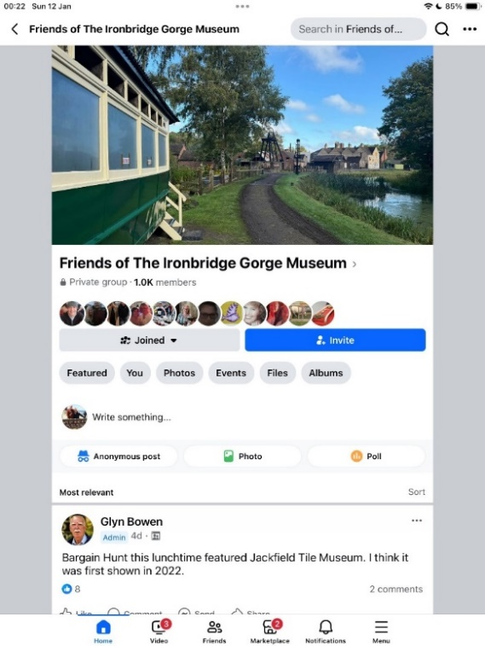You can become part of that support by joining the Friends via the Friends Administrator at: [Friends@ironbridge.org.uk](mailto:Friends@ironbridge.org.uk) and keep up with the latest news of our and the Museum’s activities by joining the Friends Facebook Page at: Friends of Ironbridge Gorge Museum Trust. Or by joining us on Instagram: @friendsofigm.

As a Friend you will be entitled to attend our monthly programme of talks, receive our Newsletter, enjoy exclusive experiences that enable you to meet the Curators and take behind the scenes tours, plus you will have the benefit of unlimited access to all Museum sites (during normal opening hours) a 10% discount on your retail and catering purchases at the Museum, Special Event discounts along with free car parking at the Museum sites.

**Friends Talks Programme 2025**

The Friends Talks are held in the Glass Classroom at Coalbrookdale (unless otherwise specified) and provide an interesting mix of topics related to the industrial age in general and the Ironbridge Gorge in particular, free to the Friends but available to anyone else at £1 admission.

**Friends Talks Programme January 2025 – September 2025**

**To be held in the Glass Classroom at Coalbrookdale (unless stated otherwise) on the following Wednesdays:**

* **22nd January at 2.30pm: Ironbridge Gorge to Silicon Valley … How disruptive tech entrepreneurs reimagine the world by Paul Green.** Paul will explore how Ironbridge Gorge tech entrepreneurs unwittingly provided a model for today’s tech community to reimagine the world by transforming it through extraordinary disruptive behaviour. Paul is a tech entrepreneur with a background in science, engineering and the wider business community – he is also an Anglican lay minister.

**NB This talk will be held in the Board Room of the Offices at Coalbrookdale**

* **26th February at 2.30pm: A field somewhere near Broseley … Cropmarks and Geophysics by Alan Smith.** The dry summer of 2018 revealed clear cropmarks in this field which has connections with the Caughley China Works and other industrial activities; working with IGMT’s partner Keele University the site was used as training site for ground science students in the use of Resistivity, Magnetometry and Ground Penetrating Radar equipment and their results will help tell the history of the field along with the help of historic maps.
* **26th March at 2.30pm: The Coalbrookdale Archives Lecture: Iron Maidens, uncovering the lives of the daughters of the Dale by Matthew Stevens.** As an historian Matthew has been researching the lives of the Darby Women in support of a forthcoming exhibition.
* **9th April at 7.30pm: Friends AGM** to be followed by **Bridges of the Severn by Steve Dewhirst.** Of the seven bridges in the Ironbridge Gorge some will be well known to all but others not so and the talk aims to rectify this.
* **7th May at 2.30pm: LTC Rolt – Beyond the Landscape by Victoria Owens.** An eminent industrial history biographer, Victoria has just published her biography of Tom Rolt and will share her insights into this leading figure of the industrial heritage movement.
* **21st May at 2.30pm: Tea Ladies by Kate Cadman.** Kate is the Museum’s Collections Curator and will chronicle the history of tea drinking from both sides of the ceramic cup – this talk was postponed from November 2024 due to the unseasonal snowfall.
* **18th June at 7.30pm: The Coalport Ferry Disaster by Robert Herrick.** The Ferry disaster in 1799 cost 28 people their lives, many of them women and children yet remains relatively unknown due to its lack of being reported on at the time. Robert has researched extensively into this tragedy, trying to give names to the victims and identify their resting places whilst campaigning for a permanent memorial to them.
* **16th July at 2.30pm: An introduction to the Soldiers of Shropshire Museum by Richard Gough.** Now Director of the Museum and formally Volunteer Manager at IGMT Richard will tell of the journey to convert a Regimental Museum to the KSLI (King’s Shropshire Light Infantry) into a fitting memorial to *all* soldiers of Shropshire.
* **17th September at 2.30pm: Brunel by Professor Andrew Kelly.** Professor Kelly is currently engaged in writing/editing an updated version of LTC Rolt’s biography of this great engineer and will share some of his findings.