**An update from the Friends Committee (September 2024)**

As the main visitor summer season comes to a close it is time to reflect not only on a busy schedule of activities offered by the Museum but on the contribution of the Friends to them. The Friends provided a programme of guiding at Coalbrookdale Museum of Iron, Coalport China Museum, Jackfield Tile Museum and the Broseley Pipeworks along with curatorial duties at the Darby Houses and the ‘Science of Iron’ exhibition at Coalbrookdale as well as supporting the Tar Tunnel Tours and volunteering in various capacities at Blists Hill Victorian Town.

A magnificent achievement, providing no small contribution to the quality of the experience received by visitors to the Ironbridge Gorge Museums but just an example of the type of support the Friends have been offering to the Museum for 55 years.

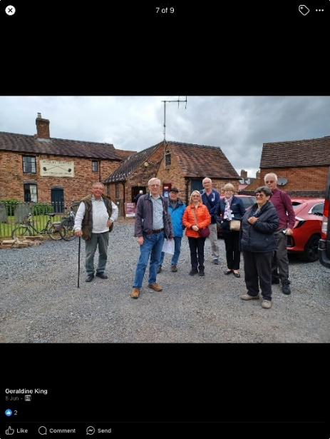Membership of the Friends takes many forms in the support it offers the Museum; volunteer guiding is a more public form of support but there are many opportunities for behind-the scenes support at the various Museum sites, in the Archives, working with the ‘Steam Team’ or assisting in a varied range of activities that extend from costumes to engines! By joining the Friends, you are not only providing financial support to the Museum but have the opportunity to utilise your skills, learn new ones or simply extend your network of friends; your membership will help spread the message about the Museum and the work of the Friends in supporting it.

*Friends gather for a tour of the Broseley ‘Jitties’ following a guided tour of the Broseley Pipeworks*

As a Friend you will be entitled to attend our monthly programme of talks, receive our Newsletter and enjoy exclusive experiences that enable you to meet the Curators and take behind the scenes tours, plus you will have the benefit of unlimited access to all Museum sites (during normal opening hours) a 10% discount on your retail and catering purchases at the Museum, Special Event discounts along with free car parking at the Museum sites.

**Friends Talks Programme Autumn 2024**

The Friends Talks are held in the Glass Classroom at Coalbrookdale and provide an interesting mix of topics related to the industrial age in general and the Ironbridge Gorge in particular, free to the Friends but available to anyone else at £1 admission.

**Autumn Talks schedule (Wednesdays)**

* **18 September 7.30pm – The Legacy of Abraham Darby’s first cooking pot: 300 years of three legs and a belly** by Richard Williams, noted historian and metallurgist, which will shed light on the early work of the first Darby in the Dale.
* **16 October 2.30pm – Black Contributions to British History: A celebration of Black History Month** by Alun Morgan former Humanities Advisor for Shropshire
* **6 November 7.30pm – Annual Joint Meeting with Broseley Local History Society: Debunking the Iron Bridge!** By David de Haan, a world expert on the Iron Bridge, who will address some of the myths surrounding it.
* **20 November 2.30pm – Tea Ladies** by Kate Cadman, Collections Curator at the Ironbridge Gorge Museum Trust, who will chronicle the history of tea drinking from both sides of the ceramic cup!

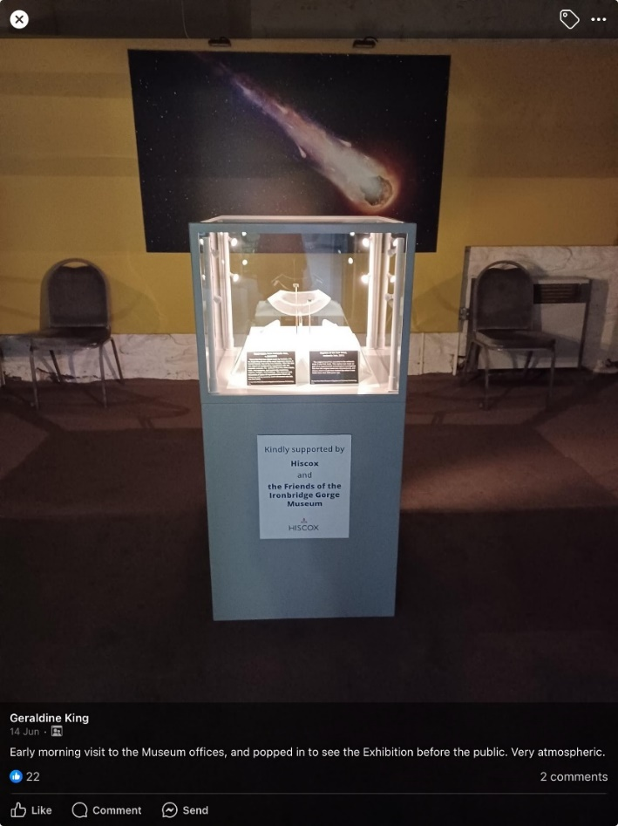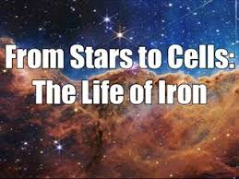Amongst the major commitments from the Friends this year is the curating of the current exhibition ‘From Stars to Cells: The Life of Iron’ in the Coalbrookdale Gallery. This exciting exhibition with its collection of meteorites and visual accounts of the ‘Big Bang’ contains examples of local finds from the Iron Age in Shropshire 2,750 years ago. The prime exhibit though is an example of the earliest known piece of worked meteorite iron from pre–Dynastic Egypt (over 5,200 years old) on loan from the Petrie Museum, University College London which is exhibited in its own display case purchased by the Friends at a cost of £8,000 (see picture to the right.)

The support of the Friends, both financial and in terms of volunteer hours, is an example of the difference the Friends can make to the Museum where, by working together, a level of success can be achieved that would otherwise not be possible.

Whether you are an aspiring engineer keen to get your hands on a steam engine, a budding Archivist anxious to delve into the history of the Ironbridge Gorge or a crafter able to offer your skills, there is a role in which you can contribute through the Friends to the success of the Museum. It might be your organisational skills that can best help or your ability to tell a good tale, whatever it is there will be a way you can help as a Friend and if none of this applies then just coming along to our programme of talks and activities will not only broaden your knowledge but widen your friendship circle. Put simply, membership of the Friends in any capacity will help support the Museum.

The support of the Friends to the Ironbridge Gorge Museum Trust throughout the past 55 years has been acknowledged by the Trust as being vital to its existence, helping in its mission to preserve, interpret and explain the industrial history of the Ironbridge Gorge.

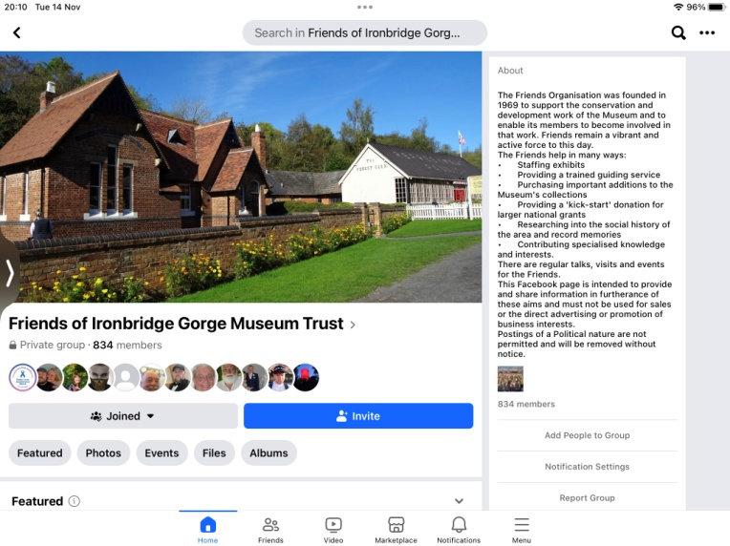You can become part of that support by joining the Friends via the Friends Administrator at: [Friends@ironbridge.org.uk](mailto:Friends@ironbridge.org.uk) and keep up with the latest news of our and the Museum’s activities by joining the Friends Facebook Page at: Friends of Ironbridge Gorge Museum Trust. Or by joining us on Instagram: @friendsofigm.

If a role as a volunteer is something that might interest you the Volunteer Coordinator, Sharon Sinclair, would be delighted to hear from you. A variety of roles exist from costumed support to ‘behind the scenes’, Sharon can be contacted on: [sharon.sinclair@ironbridge.org.uk](mailto:sharon.sinclair@ironbridge.org.uk) Volunteer Coffee Mornings are held on the first Friday of each month, a good way to find out more and meet people; contact Sharon for details of the venue and topic of the next one.